BTEC Learner Assessment Submission and Declaration

When submitting evidence for assessment, each learner must sign a declaration confirming that the work is their own.

Learner Name: | Sebastian Archer
Assessor Name: | Karl Evans
BTEC Programme Title: | BTEC L2 Information Creative Technology
Unit or Component Number and Title: | Unit 21 – A Technology Business
Assignment Title: | Assignment 1 – investigate successful technology-based product(s) and service(s)
Date Assignment Submitted: | 01/03/2022

Please list the evidence submitted for each task. Indicate the page numbers where the evidence can be found or describe the nature of the evidence (e.g. video, illustration).

Assignment task reference | Evidence submitted
A.P1
A.M1
A.D1

Learner declaration

I certify that the work submitted for this assignment is my own. I have clearly referenced any sources used in the work. I understand that false declaration is a form of malpractice.

Learner signature: Sebastian Archer Date: 01/03/2022

Tesla Car - Product

Features:
- It has a touchscreen.
The touchscreen has several uses, some of which include access to streaming services, in case you would like to enjoy a video while waiting for someone to get into your car. You can use the touchscreen to control the climate inside of the car, with options like temperature, direction, and speed of the airflow it is producing. It can also be used to protect the vehicle with a PIN, which would be required to be inputted before being able to drive.

- Autopilot for Autonomous Driving
It is a suite of an advanced driver-assistance system, which can physically drive the vehicle itself on a highway or open road. It may have trouble with smaller or rural areas.
It required active driver supervision to be able to operate, in case of a malfunction or issue with the road ahead.

- Supercharging is used to quickly charge the car battery.
Superchargers are ideal for long distance travel and are designed to charge your Tesla quickly so you can get back on the road. Charging Speeds to vary between vehicle models. To locate a supercharger, you can use the touchscreen map function.

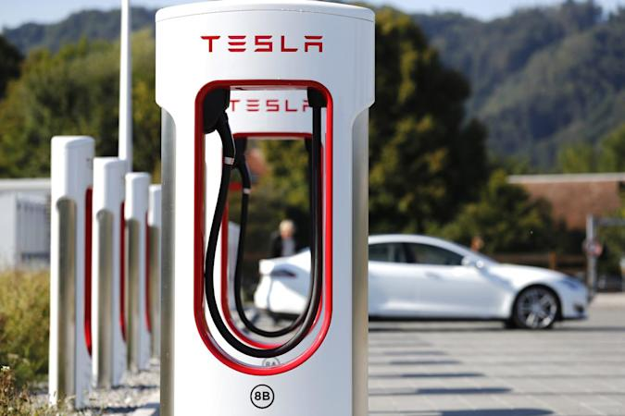

- Keycard access allows you to enter your car with only a card.
The Keycard is only intended for the Model 3.
It uses RFID to communicate with the car.

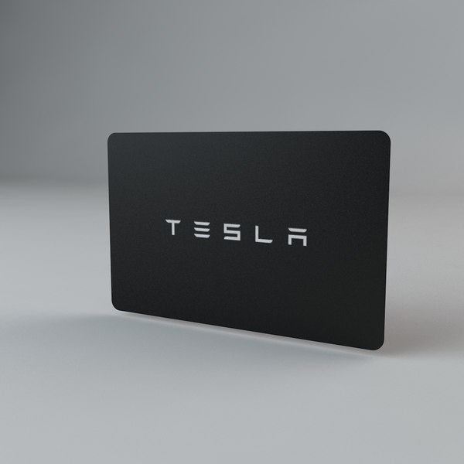
- Fart Mode, where you can make your Tesla make fart noises when different actions are made like indicating or steering. See more in the video below:
(https://www.youtube.com/watch?v=seEVSFq3FmE)

- Connects to Wi-Fi to play games, watch movies, and listen to music on the go via the touchscreen. It synchronises with the Tesla network which can provide you with the latest features and services for your enjoyment.

(Continue)

Functions:

      - Roll down the windows on the doors
      - Storage Area in the front and back - With front and rear trunks and fold-flat seats, Model S is a luxury car where you can fit your bike without taking the wheel off, and your luggage too.
      - Onboard Diagnostics – This can search every aspect of the car for problems, where they could be software errors, hardware errors, or even problems with the exterior of the car.
      - Air Conditioning – Air Conditioning can help the climate inside your car. It can change the temperature to suit the driver’s needs, whether they like the car hot or cold.
      - Battery Powered – The Tesla is completely battery powered! It can last up to 300 miles on one charge, also this may change depending on outside conditions.
- 17” Cinematic Display with 2200x1300 resolution, ultra-bright, true colours and exceptional responsiveness, the new centre display is the best screen to watch anywhere.
- Stay Connected. Multi-device Bluetooth, wireless and USB-C charging for every passenger, with enough power to fast-charge your tablets and laptop.

Cameras

s



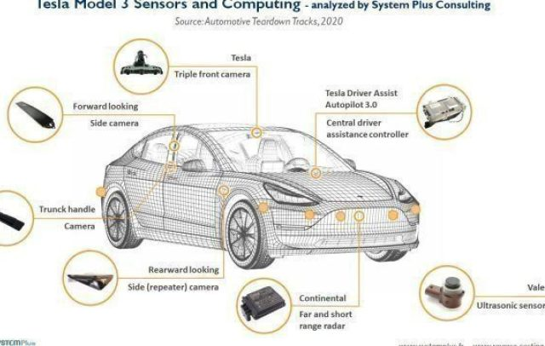

Here is a layout the vehicle’s special features.

Steam - Service

Features of Steam:
Easy Purchase of Games – You're able to purchase any game quickly and easily you would like that is available on the platform without the hassle or delivery times.
Added Controller Support for Games – Games that do not support controllers can be used with controllers thanks to steams controller emulation support for keyboard only games.
Steam Chat – Chat with your friends on Steam! Text or Call at any time thanks to steams built in communications.
Game Hubs – Game hubs are a designated place for people to talk about the specific game it is assigned to and post user-created content that other people can view and use.
Broadcasting – People can broadcast games for people to watch live on game hubs.
Steam Workshop – The steam workshop is used for people to share content they have created for games.
Achievements – Achievements are used for when a specific thing has happened in a game. It acts as an award to the player.

Functions:

Search for discounted games on the platform – You’re able to filter games on the store by discounted or cheapest for you to find games that are within your budget.
Add multiple games to a shop basket – You’re able to mass purchase as many games as you would like at once.
React to messages in steam chat – Thanks to the many features of Steam Chat, you can right click on a message, and then react to it with a range or different emojis to show if you’re happy, angry, or sad with the message.
Share links and posts with people – You can post links to people, and steam will automatically embed links to show people what is at the end of the link.
Custom controllers with games – Steam can emulate different controllers to whatever your game supports, so if it’s a game that only supports an xbox controller and you want to use a ps4 or 5 controller then this will unlock that feature for you.

Task 2:

Tesla:

The features of the camera on the Tesla are useful because they can help direct the driver or provide insight to what caused damage done to the vehicle.

Autopilot enables your car to steer, accelerate and brake automatically within its lane under your active supervision, assisting with the most burdensome parts of driving. With over-the-air software updates, the latest enhancements are available instantly.

Auto parking – The vehicle can park itself via automated controls and sensors on the outside.

Steam:

The benefits of steam are great, compared to other platforms.

Everything is completely digital.
Developers can release updates for their games whenever they want.
Games are account based
Games often go on sale

Comparing:

Some other launchers like this are Battle.NET and Epic Games Launcher

Steam is more advanced than both these platforms and it is highly unlikely that they will surpass Steam in the gaming market.

